FILE SYSTEM( chapter 4)

  - File
- A file is sequence of logical records i.e. a sequence of bits and bytes.
- A file is a named collection of related information that is recorded on secondary storage such as magnetic disks, magnetic tapes and optical disks.
- In general, a file is a sequence of bits, bytes, lines or records whose meaning is defined by the files creator and user.

File System
  - A file system is the methods and data structures that an operating system uses to keep track of files on a disk or partition; that is, the way the files are organized on the disk.
  - The word is also used to refer to a partition or disk that is used to store the files or the type of the file system.

File Attributes
A file has a name and data. Other than this, it contains information like date and time of file creation, file’s current size etc. with a file. These are known as attributes of a file. The lists of file attributes are:
Name –only information kept in human-readable form Identifier–unique tag (number) identifies file within file system Type–needed for systems that support different types
Location–This information is a pointer to a device and to the location of the file on that device
Size–current file size and possibly the maximum allowed size
Protection–Access-control information determines who can do reading, writing, executing
Time, date, and user identification –data for protection, security, and usage monitoring etc.

File Naming
  - When a process creates a file, it gives the file a name. When the process terminates, the file continues to exist and can be accessed by other processes using its name.
  - File naming = File name + File extension
  - Eg. bcabit.doc In this example the bcabit is the file name and doc is the file
  - Some common file extension are: DOC and DOCX, .HTML and .HTM,.ODT,.PDF,.XLS and XLSX, .ODS, .PPT and .PPTX ,.TXT etc

File Operation
CREATE: A blank file is created.
DELETE: The purpose of this system call is to delete this file
OPEN: Open a file either for reading or writing.
CLOSE: When a file is no longer accessed.

READ: When a file is only to be read.
WRITE: To write some data on file.
APPEND: To add some data to the end of the file.
RENAME: To rename the file.

File Structure:
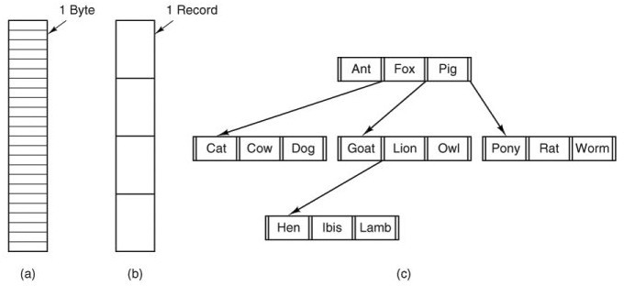

Three kinds of files. (a) Byte sequence. (b) Record sequence. (c) Tree.

Directories
Directory is the collection of files. The directory contains information about the files, including attributes, location and ownership. Much of this information especially that is concerned with storage is managed by the operating system. The directory is itself a file, accessible by various file management routines.

Information contained in a device directory
- Name
- Type
- Address
- Current length
- Maximum length
- Date last accessed
- Date last updated
- Owner id
- Protection information

Directory Operations

  - CREATE: A directory is created.
  - DELETE: A directory

  - OPENDIR: Directories can be opened for reading it.
  - CLOSEDIR: When a directory has been read, it should be closed to free up internal table space in main memory.
  - RENAME: Directories can be renamed just like files.

Advantages of maintaining directories

- Efficiency: A file can be located more quickly.
- Naming: It becomes convenient for users as two users can have same name for different files or may have different name for same file.
- Grouping: Logical grouping of files can be done by properties e.g. all java programs, all games etc.

Types of directories
A directory system can be classified in to single level and hierarchical directory system:
1) Single-Level Directory
The single-level directory is the simplest directory structure. In it, all files are contained in the same directory which makes it easy to support and understand.
A single level directory has a significant limitation, however, when the number of files increases or when the system has more than one user. Since all the files are in the same directory, they must have a unique name. If two users call their dataset test, then the unique name rule violated.

- Since it is a single directory, so its implementation is very easy.
- If the files are smaller in size, searching will become faster.
- The operations like file creation, searching, deletion, updating are very easy in such a directory structure.
Advantages
- Logical Organization: Arrange files hierarchically for easy navigation.
- Efficiency: Faster file searching and access.
- Security: Restrict access at directory level to protect data.
- Backup & Recovery: Simplifies locating and restoring files.
- Scalability: Easily supports growth with new files and directories
Disadvantages
- There may chance of name collision because two files can have the same name.
- Searching will become time taking if the directory is large.
- This can not group the same type of files together.

2) Two-Level Directory
In a two-level directory structure, each user has a separate User File Directory (UFD) containing only their files. A Master File Directory (MFD) stores entries for all users and points to their respective UFDs, preventing filename conflicts between users.
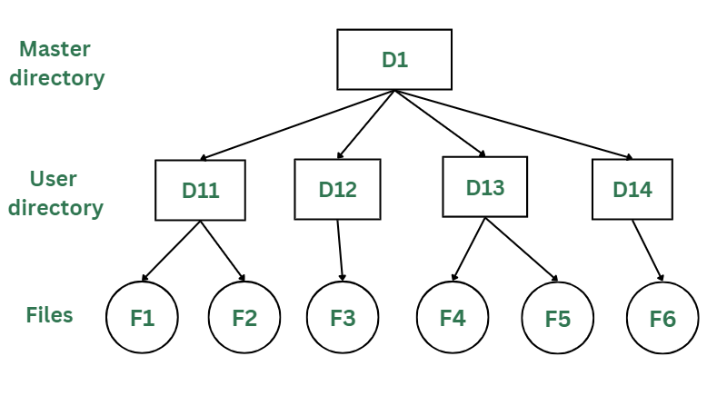Two-Levels Directory Structure
Advantages
- The main advantage is there can be more than two files with same name, and would be very helpful if there are multiple users.
- A security would be there which would prevent user to access other user's files.
- Searching of the files becomes very easy in this directory structure.
Disadvantages
- As there is advantage of security, there is also disadvantage that the user cannot share the file with the other users.
- Unlike the advantage users can create their own files, users don't have the ability to create subdirectories.
- Scalability is not possible because one user can't group the same types of files together.
3) Tree Structure/ Hierarchical Structure
The tree directory structure is the most common in personal computers. It resembles an upside-down tree, with the root directory at the top containing all user directories. Each user can create files and subdirectories within their own directory but cannot access or modify the root or other users’ directories.
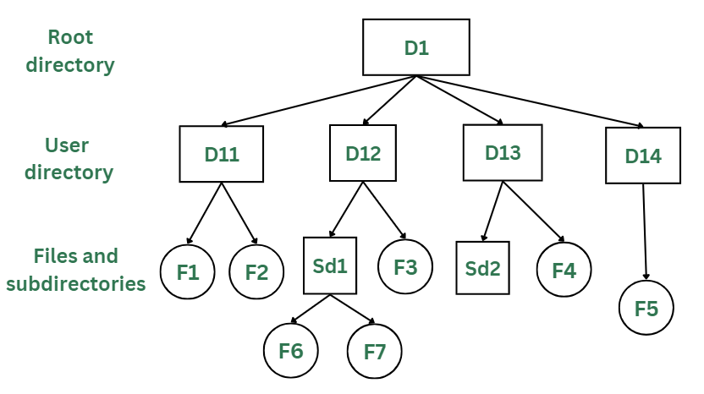Tree/Hierarchical Directory Structure
Advantages
- This directory structure allows subdirectories inside a directory.
- The searching is easier.
- It helps in organizing files by importance, making important files easier to locate.
- This directory is more scalable than the other two directory structures explained.
Disadvantages
- As the user isn't allowed to access other user's directory, this prevents the file sharing among users.
- As the user has the capability to make subdirectories, if the number of subdirectories increase the searching may become complicated.
- Users cannot modify the root directory data.
- If files do not fit in one, they might have to be fit into other directories.

File Access method

File access methods are techniques used by an OS to read and write data in files. They define how information is organized, retrieved, and modified. Choosing the right method is important for performance and data management.
There are three ways to access a file in a computer system:
- Sequential-Access
- Direct Access
- Index sequential Method
Sequential Access
A file access method where data is read or written in order, one record after another, starting from the beginning. The file pointer moves forward automatically after each operation.
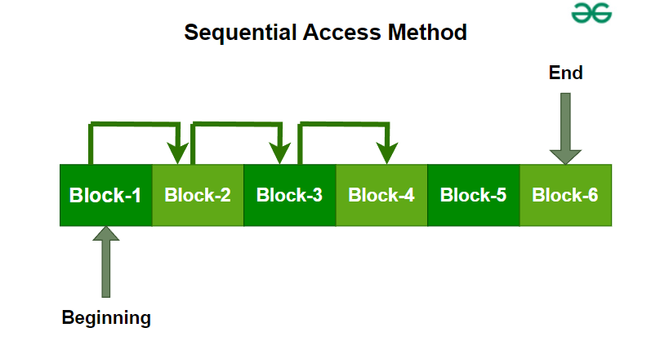Sequential Access Method

- Data is accessed from one record right after another record in an order.
- When we use the read command, it moves ahead pointer by one.
- When we use the write command, it will allocate memory and move the pointer to the end of the file.
- Such a method is reasonable for tape.
Advantages of Sequential Access Method
- It is simple to implement this file access mechanism.
- It uses lexicographic order to quickly access the next entry.
- It is less prone to data corruption as the data is written sequentially and not randomly.
Disadvantages of Sequential Access Method
- Slow for searching specific records.
- Inserting/updating in the middle is difficult.
- Can waste storage if records have varying lengths.

Direct Access Method
A file access method that allows data to be read or written directly at any block or record, using its address (block number). It supports random access without scanning previous records.
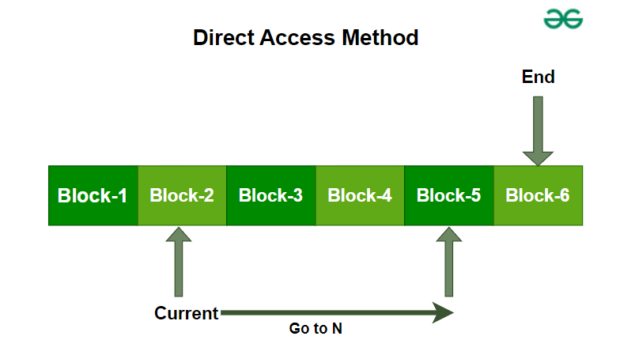Direct Access Method
Advantages of Direct Access Method
- The files can be immediately accessed decreasing the average access time.
- In the direct access method, in order to access a block, there is no need of traversing all the blocks present before it.
Disadvantages of Direct Access Method
- Complex Implementation : Implementing direct access can be complex, requiring sophisticated algorithms and data structures to manage and locate records efficiently.
- Higher Storage Overhead : Direct access methods often require additional storage for maintaining data location information (such as pointers or address tables), which can increase the overall storage requirements.
Index Sequential method
It is the other method of accessing a file that is built on the top of the sequential access method. These methods construct an index for the file. The index, like an index in the back of a book, contains the pointer to the various blocks. To find a record in the file, we first search the index, and then by the help of pointer we access the file directly.
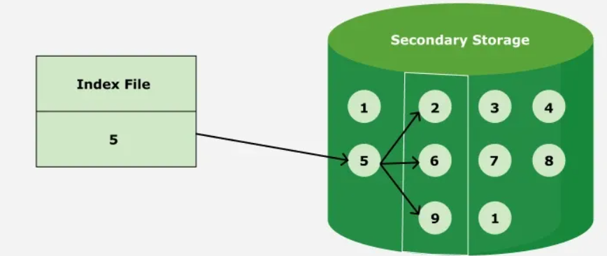Index Access Method
- It is built on top of Sequential access.
- It control the pointer by using index.
Advantages of Index Sequential Method
- Fast Searching: Index enables quick lookups.
- Flexible: Supports both sequential and random access.
- Reduced Access Time: Quickly locates data in large files.
Disadvantages of Index Sequential Method
- Complexity: Harder to implement and maintain than sequential access.
- Extra Storage: Requires additional space for indexes.
- Slower Updates: Both data and index must be updated during insertions, deletions, or modifications.
- Maintenance Overhead: Indexes need frequent updates in dynamic environments.

File System Implementation

The allocation methods define how the files are stored in the disk blocks. There are three main disk space or file allocation methods.
- Contiguous Allocation
- Linked Allocation
- Indexed Allocation
The main idea behind these methods is to provide:
  - Efficient disk space utilization.
  - Fast access to the file blocks

Contiguous Allocation
In this scheme, each file occupies a contiguous set of blocks on the disk. For example, if a file requires n blocks and is given a block b as the starting location, then the blocks assigned to the file will be: b, b+1, b+2,……b+n-1. This means that given the starting block address and the length of the file (in terms of blocks required), we can determine the blocks occupied by the file.
For example, If we have a disk with 1 KB blocks, then for storing a 50 KB file, we will require 50 consecutive blocks.

The file allocation table in contiguous allocation contains
  - Address of starting block
  - Length of the allocated portion.

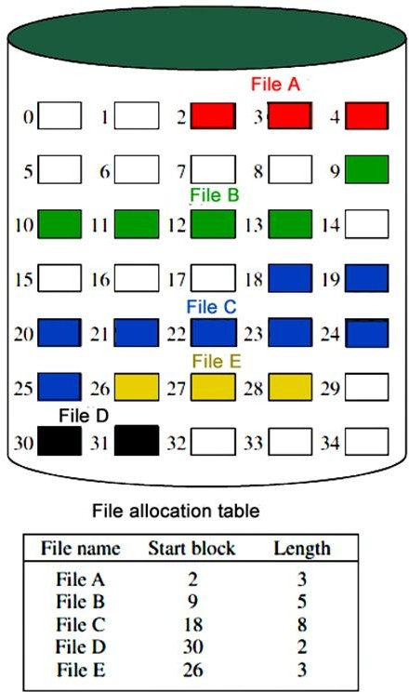

The file ‘File A’ in the above figure starts from the block 2 with length = 3 blocks. Therefore, it occupies 2,3 and 4 blocks.

Advantages:
    - Both the Sequential and Direct Accesses are supported by this. For direct access, the address of the kth block of the file which starts at block b can easily be obtained as (b+k).
    - This is extremely fast since the number of seeks are minimal because of contiguous allocation of file blocks.

Disadvantages:
    - This method suffers from both internal and external fragmentation. This makes it inefficient in terms of memory utilization.
    - Increasing file size is difficult because it depends on the availability of contiguous memory at a particular instance.

- Linked Allocation (Non-contiguous allocation)

In this scheme, each file is a linked list of disk blocks which need not be contiguous. The disk blocks can be scattered anywhere on the disk.

The file allocation table contains a pointer to the starting and the ending file block. Each block contains a pointer to the next block occupied by the file.

The file ‘jeep’ in following image shows how the blocks are randomly distributed. The last block
- contains -1 indicating a null pointer and does not point to any other block.
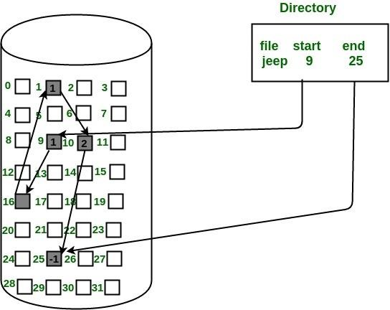

Advantages:

  - This is very flexible in terms of file size. File size can be increased easily since the system does not have to look for a contiguous chunk of memory.
  - This method does not suffer from external fragmentation. This makes it relatively better in terms of memory utilization.

Disadvantages:

  - Because the file blocks are distributed randomly on the disk, a large number of seeks are needed to access every block individually. This makes linked allocation slower.
  - It does not support random or direct access. We cannot directly access the blocks of a file. A block k of a file can be accessed by traversing k blocks sequentially (sequential access) from the starting block of the file via block pointers.
  - Pointers required in the linked allocation incur some extra overhead.

Indexed Allocation (i-nodes)

In this scheme, a special block known as the Index block contains the pointers to all the blocks occupied by a file. Each file has its own index block. The i^{th} entry in the index block contains the disk address of the i^{th} file block. The directory entry contains the address of the index block as shown below:
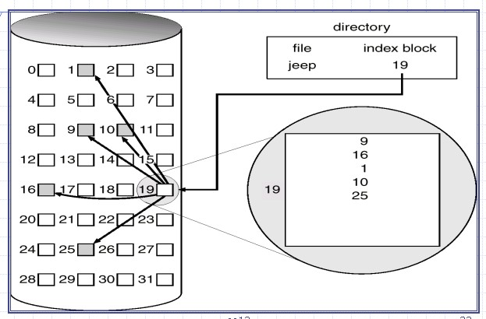
- nodes can point directly or indirectly as follows:
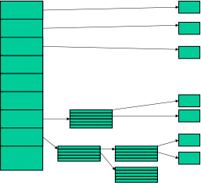

Advantages:
  - This supports direct access to the blocks occupied by the file and therefore provides fast access to the file blocks.
  - It overcomes the problem of external fragmentation.

Disadvantages:

  - The pointer overhead for indexed allocation is greater than linked allocation.

  - For very small files, say files that expand only 2-3 blocks, the indexed allocation would keep one entire block (index block) for the pointers which is inefficient in terms of memory utilization. However, in linked allocation we lose the space of only 1 pointer per block.

Protection in Operating System (OS)

Protection in an Operating System refers to the mechanism that controls access to system resources so that only authorized users or processes can use them in an approved way.
Goal: prevent misuse, damage, and interference.

Types of Access (Access Rights)
Access rights define what kind of operation can be performed on a resource.
Common Types of Access
- Read (R) – view the contents
Example: read a file
- Write (W) – modify the contents
Example: edit a file
- Execute (X) – run a program
Example: execute an application
- Append (A) – add data at the end
Example: add logs to a file
- Delete (D) – remove a resource
Example: delete a file
- Create (C) – create a new resource
Example: create a file or process

Access rights depend on the resource
Resource | Possible Access
File: | Read, Write, Execute, Delete
Memory: | Read, Write
CPU: | Execute
Device: | Read, Write

Access Control Lists (ACLs)
An Access Control List (ACL) is a table or data structure that tells an Operating System which access rights a specific user or system process has to a particular object (such as a file, directory, or network interface).
- The Object: The resource being protected (File, Folder, Hardware).
- The Subject: The entity requesting access (User, Group, Process).
- ACE (Access Control Entry): An individual line/rule within an ACL.
Why ACLs
In traditional Unix-like systems, permissions are limited to UGO (User, Group, Others).
- Problem: If you want to give access to 3 specific users who aren't in the same group, traditional permissions fail.
- Solution: ACLs provide Granular Control, allowing you to define permissions for any number of individual users or groups.

Each entry in an ACL typically contains:
- Identifier: Who it applies to (e.g., UID: 1001 or User: Alice).
- Permissions: What they can do (Read, Write, Execute, Delete, Change Permissions).
- Type: Is this rule an Allow or a Deny?
Primary Types of ACLs
A. Discretionary ACL (DACL)
- The most common type used for security.
- Managed by the owner of the object.
- Determines who has "discretion" to access the file.
B. System ACL (SACL)
- Used for Auditing.
- Does not block users; instead, it "watches" them.
- Example: Logs an entry in the System Journal every time an Admin accesses the "Payroll" folder.
C. Default vs. Access ACLs (Linux POSIX)
- Access ACL: Specific permissions for a file/folder.
- Default ACL: Applied to a directory only; ensures any new file created inside inherits specific permissions automatically.

